SIMATS ENGINEERING
ASSESSMENT TOOL 2 – COMPLETED ASSIGNMENT
COURSE NAME: INTERNET PROGRAMMING | COURSE CODE: CSA43

COURSE OUTCOME COVERED
CO-1: Develop well-structured, standards-compliant web pages using HTML/XHTML and XML, and apply Internet protocols and HTTP communication mechanisms for web content delivery (L2).
Assessment Tool: Data Interpretation | Weightage: 20% | Total Marks: 20
Student Name: N. Sai Preethika Register Number: 192372344

1. HTTP Response Analysis
Given response header:
HTTP/1.1 200 OK
Date: Mon, 01 Apr 2026 10:00:00 GMT
Content-Type: text/html
Content-Length: -150
Connection: keep-alive

1. Identify any incorrect or invalid fields in the header.
The clearly invalid field is Content-Length: -150. Content-Length specifies the size of the message content in bytes and cannot be negative. The Date field is also inconsistent: 1 April 2026 falls on a Wednesday, not a Monday. The status line, Content-Type: text/html, and Connection: keep-alive are otherwise plausible for an HTTP/1.1 response, assuming persistent connections are supported.
2. Analyze the issue with Content-Length and explain its impact.
A negative Content-Length is invalid because a message body cannot have a negative number of bytes. A recipient may reject the malformed response or fail to process it reliably. Incorrect message-length information can also make it unclear where a response ends, affecting connection reuse and subsequent responses. The server should send the actual non-negative byte length of the response body, or use the applicable HTTP message-framing rules when Content-Length is not sent.
3. Determine whether the status code matches the response correctness.
The status code 200 OK indicates that the request succeeded; it does not guarantee that every response header is valid. Because the supplied response contains an invalid Content-Length and an inconsistent Date value, the response as a whole is not correct. If the request succeeded and the response is properly framed, 200 OK may still be the appropriate status after the header errors are corrected.
4. Suggest corrections for the identified errors.
Replace Content-Length: -150 with the actual number of bytes in the HTML response body. Use Content-Length: 150 only if the body is exactly 150 bytes. Correct the Date header; if the intended timestamp is 1 April 2026 at 10:00 GMT, the weekday should be Wed, so the value would begin “Wed, 01 Apr 2026 10:00:00 GMT”. Ideally, let the server generate the Date and calculate the content length automatically.

2. DOM Structure Analysis
Given structure:
<html>
<head>
<title>Test Page</title>
</head>
<body>
<div>
<p>Hello World
</div>
</body>
</html>

1. Identify missing or improperly closed elements.
The <p> element is missing its explicit closing tag </p> before </div>. The document also omits the HTML5 doctype and the lang attribute on <html>. The other displayed elements have closing tags. A browser may automatically close the paragraph during parsing, but explicit valid markup is clearer and more reliable.
2. Analyze how the browser will interpret this structure.
HTML browsers use defined error-recovery rules for incomplete markup. When the parser encounters </div>, it implicitly closes the open paragraph before closing the div. The browser can therefore build a usable DOM rather than stopping. However, in more complex documents, recovery can produce a DOM different from what the author intended, so developers should not rely on it.
3. Determine the impact on rendering and layout.
The browser will likely display “Hello World” as a paragraph inside the div, so the visible result may appear normal. However, omitted closing tags can cause unexpected behaviour when more elements are added and can affect paragraph spacing, CSS selectors, scripts that traverse the DOM, and accessibility interpretation. Omitting a doctype can also trigger quirks mode in some circumstances and cause inconsistent layout calculations.
4. Suggest corrections to make the DOM valid.
Add <!DOCTYPE html>, set the document language, include standard metadata, and close the paragraph explicitly:
<!DOCTYPE html>
<html lang="en">
<head>
<meta charset="UTF-8">
<meta name="viewport" content="width=device-width, initial-scale=1.0">
<title>Test Page</title>
</head>
<body>
<div>
<p>Hello World</p>
</div>
</body>
</html>

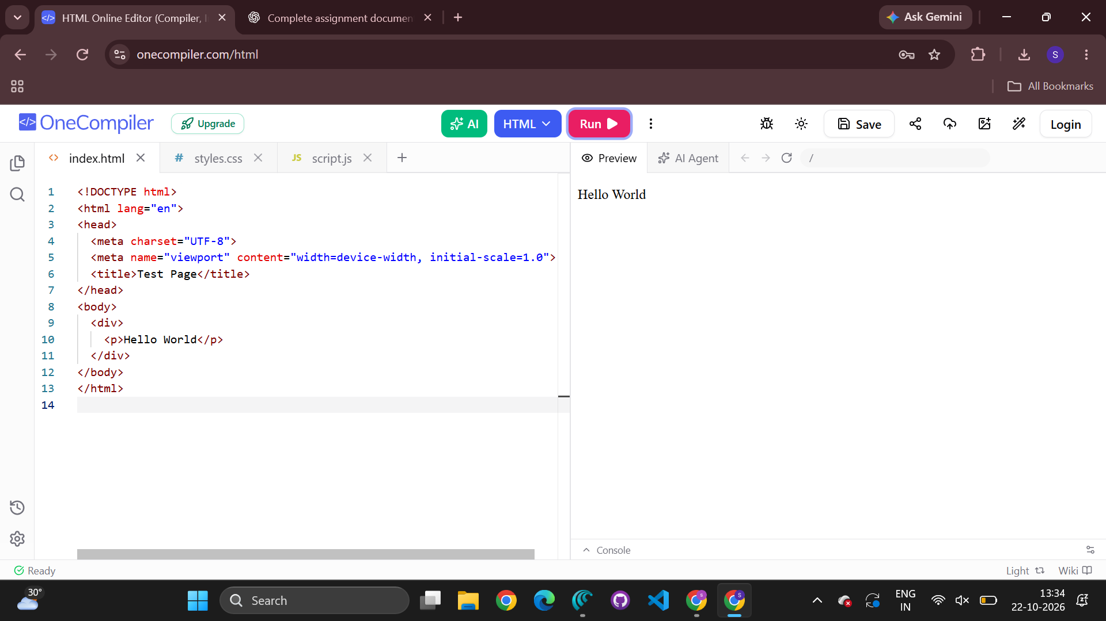

3. GET vs POST in Login System
The given comparison shows GET placing credentials in the URL query string and POST placing them in the request body.
Method | Example / visibility | Security level shown
GET | /login?user=admin&pass=1234 — visible in URL | Low
POST | /login — data sent in request body | Moderate; HTTPS is still needed
1. Interpret the differences in data transmission between GET and POST.
With GET, successful form values are appended to the URL as a query string. These values may appear in browser history, server logs, shared links, and monitoring records. GET is generally used to retrieve resources and should not be used for passwords. With POST, form values are normally sent in the request body rather than the URL. This reduces URL exposure, but POST does not itself encrypt data or guarantee security.
2. Analyze which method is more suitable for login and why.
POST is more suitable for login because credentials are sent in the request body instead of being placed in the URL. This avoids common query-string exposures and suits the purpose of submitting authentication data. The login page and endpoint must also use HTTPS; POST alone does not provide confidentiality.
3. Identify security risks in using GET for authentication.
Passwords in GET URLs may be exposed through browser history, copied URLs, server or proxy logs, analytics systems, and referrer information. URLs can also be bookmarked or shared accidentally. These exposures may allow unauthorized parties to obtain credentials. GET does not encrypt traffic, so credentials can be observed on an unencrypted network connection.
4. Suggest best practices for secure login implementation.
Use HTTPS throughout the login flow; submit credentials using POST; validate and authenticate credentials on the server; and store passwords only as salted hashes using a suitable password-hashing algorithm. Apply rate limiting and brute-force protection, and never log passwords. Use secure session cookies with Secure, HttpOnly, and an appropriate SameSite setting, rotate session identifiers after login, and use CSRF protection where relevant. Return generic authentication errors that do not reveal whether a username exists. Client-side validation improves usability but cannot replace server-side validation.

4. HTML Code Inspection
Given snippet:
<!DOCTYPE html>
<html>
<head>
<title>Sample</title>
</head>
<body>
<h1>Welcome
<p>This is a paragraph
<img src="image.jpg">
</body>
</html>

1. Identify missing closing tags.
The <h1> and <p> elements do not have explicit closing tags. The <html>, <head>, <title>, and <body> elements are closed. The <img> element is a void element in HTML and does not require a closing tag.
2. Analyze issues with the <img> tag.
The image has a src attribute but no alt attribute. Alternative text is important for screen-reader users and is shown if the image cannot load. If the image conveys information, alt should describe its meaningful content; if it is decorative, use alt="". The relative path image.jpg must point to an available image file. Adding width and height can reserve layout space and reduce layout shifts.
3. Determine how browsers will handle these errors.
Browsers usually recover from missing heading and paragraph end tags using HTML parsing rules, so the page may still display. The image may load if image.jpg is available, but assistive technology will not receive suitable alternative text because alt is missing. Automatic recovery does not make the source well-structured or fully accessible.
4. Suggest a corrected version of the code.
The corrected version closes the heading and paragraph, adds the language and metadata, and supplies alternative text. Replace the example alt text with a description of the actual image; use an empty alt attribute if it is decorative.
<!DOCTYPE html>
<html lang="en">
<head>
<meta charset="UTF-8">
<meta name="viewport" content="width=device-width, initial-scale=1.0">
<title>Sample</title>
</head>
<body>
<h1>Welcome</h1>
<p>This is a paragraph.</p>
<img src="image.jpg" alt="Description of the image">
</body>
</html>

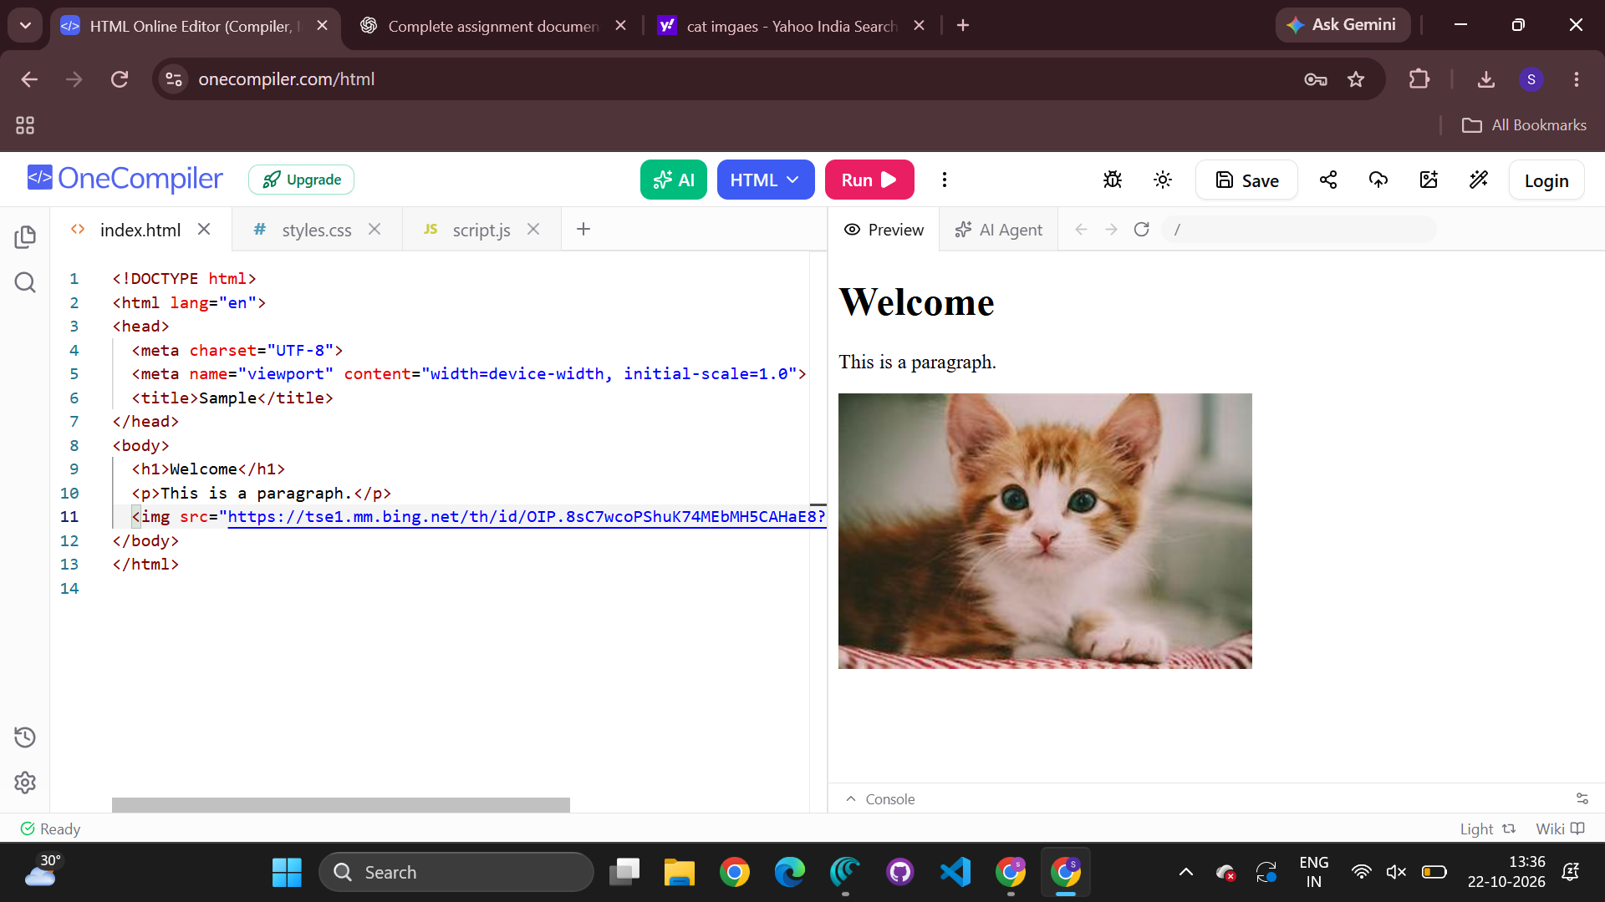

5. Browser–Server Communication Flow
Given sequence: user enters a URL → DNS lookup → HTTP request → server processes request → response is returned → browser renders the page.
1. Interpret each step in the communication flow.
1. URL entry: The browser parses the URL to identify the scheme, host, path, and any query. 2. DNS lookup: If no usable cached address exists, the browser or operating system resolves the host name to an IP address. 3. HTTP request: The browser establishes the required connection (including TLS for HTTPS) and sends a request with a method, target, headers, and, when applicable, a body. 4. Server processing: The server routes the request, runs application logic, may access databases or other services, and prepares a result. 5. Response: The server returns a status code, headers, and content or a redirect; the browser may request linked resources afterward. 6. Rendering: The browser parses HTML, builds the DOM, processes CSS, executes JavaScript, and lays out and paints the page. Images, fonts, and scripts may trigger additional requests.
2. Identify where delays can occur.
Delays may occur during DNS resolution, connection establishment, TLS negotiation, network transmission, server queueing and processing, database or third-party service calls, and delivery of large response bodies. Rendering can be delayed by large images, blocking CSS or JavaScript, expensive scripts, and complex DOM structures. Network congestion, packet loss, high latency, and a slow client device can add further delay.
3. Analyze the role of DNS in the process.
DNS translates a human-readable host name, such as example.com, into an IP address used to route network traffic. Without a valid address, the browser cannot normally connect to the intended host by name. DNS caching avoids repeated lookups and reduces latency, while incorrect records or slow/unavailable resolvers can delay or prevent access. DNS helps locate the server; it does not transmit the web page itself.
4. Suggest optimizations to improve performance.
Use reliable DNS hosting and sensible caching; enable persistent connections and modern HTTP versions where supported; and use a CDN for distributed static assets. Compress text responses with Brotli or gzip, optimize and correctly size images, and cache static resources with suitable Cache-Control headers. Reduce redirects and unnecessary requests, minimize render-blocking CSS and JavaScript, defer non-critical scripts, and remove unused code. Optimize server logic, database queries, and external API calls, and monitor real-user performance to identify bottlenecks.

Conclusion
This analysis shows that valid HTTP message framing, well-formed HTML and DOM structures, correct use of GET and POST, accessible image markup, and an efficient browser–server workflow are essential to reliable web applications. A success status code does not excuse malformed headers, and browser error recovery does not replace standards-compliant markup. Secure login requires POST together with HTTPS and sound server-side authentication practices. Performance improves when network, server, resource-loading, and rendering delays are measured and addressed.

Code of Conduct
I N. Sai Preethika/192372344 (Name / Register Number) certify that this submission is my original work and that I have adhered to the guidelines specified for this assessment. I understand that any violation of academic integrity rules will result in disciplinary action.
Signature of the student: preethika

